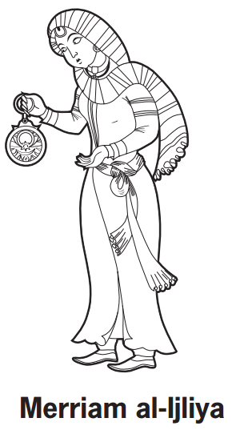

**Contribution**

**Invention**

**Background**