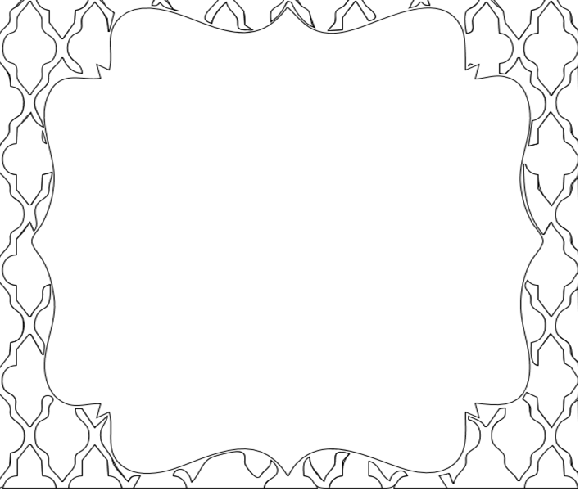

Name: ____________________________

Name: ____________________________

My first week in Islamic Studies.

My first week in Islamic Studies.