**Directions**: Answer each question on the lines below.

What does the Surah Al-Ghashiyah say about in the pictures below?

What do you think is so amazing about these things?

How are they a sign for us to reflect on Allah?

C:\Documents and Settings\teacher\Local Settings\Temporary Internet Files\Content.IE5\PYBXUQ19\MC900111646[1].wmf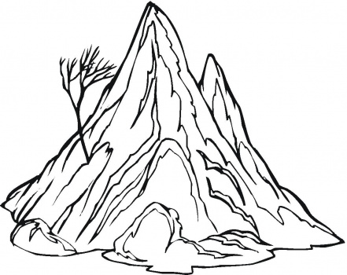

The Mountains

The Camel: ________________________________________________________________________________________________________________________________________________________________________________________________________________________________________________________________________________________________________________________________________________________________________________________________________________________________________________________________________________________________________